Risk Assessment when restarting Face-to-Face Scouting.
A guide for Solihull Scout County Leaders and adult volunteers.

Note: This summary guide should not be taken as a substitute for reading the specific guidance relevant to your role in Scouting. It is intended to draw together points from a series of documents published by the Scout Association and other parties, to assist you in the preparation and submission of Risk Assessments required to restart face-to-face Scouting activities.

A. The legal basis for Risk Assessments.

The HSE website provides some useful principles to bear in mind when preparing any Risk Assessment (RA):

'...a Risk Assessment must be suitable and sufficient, i.e. it should show that:

- a proper check was made;
- you asked who might be affected;
- you dealt with all the obvious significant risks, taking into account the number of people involved;
- the precautions are reasonable, and the remaining risk is low
- you involved your workers or their representatives in the process
The level of detail in a Risk Assessment should be proportionate to the risk and appropriate to the nature of the work.

Insignificant risks can usually be ignored, as can risks arising from routine activities associated with life in general, unless the work activity compounds or significantly alters those risks.
Your Risk Assessment should only include what you could reasonably be expected to know - you are not expected to anticipate an unforeseeable risk.'

While this text is principally intended for employers or businesses, it describes an expectation that we can adopt when preparing a RAs for Scouting.

Particular principles to consider are:

Suitable: Does the RA reflect:
-the activity being planned;
-the place that it will take place; and
-the people who will be involved?

Sufficient:Does the RA consider:
- hazards that exist or can be expected to be present during the activity;
- the likelihood of any of those hazards causing an injury; and
- the effectiveness of the controls that are already in place and are planned.

Please bear in mind that you are only expected to consider risks that it is reasonable to anticipate - you don't have to try to put controls in place for events that are very unlikely to happen.

B. The Scout Association's approach.

The Scout Association provides their own Simple Guide to Risk Assessment, which includes this diagram and explanation:

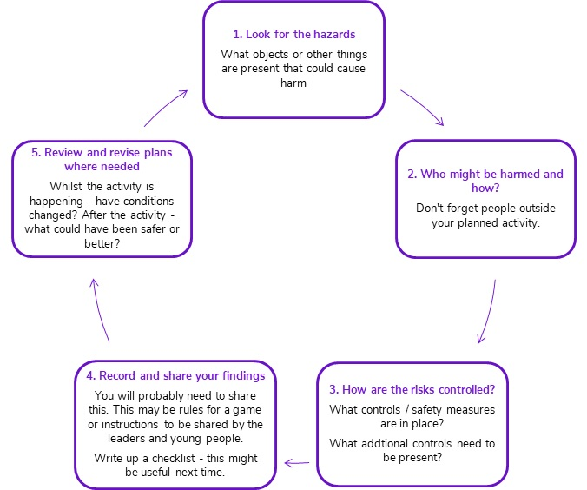

Step 1: A HAZARD is anything that can cause harm.
- In the context of activities, a hazard could be weather, equipment, the way you are doing the activity or something else.
- Look at all your activities, including non-routine tasks. Look at what actually happens, not just what should happen.
- Look for hazards which are really obvious, not every single little thing.

Step 2: WHO is involved in the activity - Young People, Adults, Visitors?
- Participants with additional needs? What could happen to cause them harm?
- A risk is the chance - high or low - that someone will be harmed by the hazard.

Step 3: CONTROLS are the way of removing or reducing risk
- Can I get rid of the hazard altogether? (E.g. not crossing a road but using a bridge or underpass).
- What is a less risky option?
- How can we reduce the risk of people being in contact with the hazard? (E.g.Use a zebra crossing rather than any busy point on the road)
- What sort of instructions do participants need for the activity? A written sheet? Simple rules for a game?
- Have you asked somebody that has done it before if they have any tips?
- Do they have to wear any protective / safety clothing e.g. gloves, climbing harness, walking boots.

Step 4: RECORD and COMMUNICATE it effectively and appropriately.
- How do you involve other leaders and young people in writing the Risk Assessment?
- How will you inform them about the risks identified and the controls in place to keep them safe?
- It's really good practice (and now a requirement) to write your Risk Assessment down.
- If you're sharing by discussing with others, make sure you have all the key points ready and don't miss them out.
- A checklist of bullet points will help you.

Step 5: REVIEW as a minimum every 12 months to see if anything has changed, or sooner if there has been a change of equipment, or if there has been an accident or near miss.

C: Getting back together after Lockdown.

The Scout Association Guidance above (updated February 2019) is still relevant, but the current situation requires us to take a more detailed approach, which includes particular precautions designed to minimise the spread of the COVID-19 infection. As a part of restarting face-to-face Scouting, leaders are required to submit RAs that cover all aspects of their planned activities, and the COVID-19 hazard in particular. The Scout Association has published a series of guidance documents for All Members, Section Leaders and Executive Committees & Commissioners, as well as Guidance for Approvers.

The recent guidance now requires Section Leaders to produce documented Risk Assessments for all face to face Scouting activities. These should cover the range of hazards outlined in the February 2019 guidance, and must also include consideration of the COVID-19 infection hazard. Risk Assessments for planned activities may be produced as a single document, describing all hazards and the associated precautions, or as a suite of RAs for the planned activity, e.g. separate RAs for: Use of the site (Local park or field, your Group HQ); the activity to be undertaken (Football, firelighting, archery); and COVID (social distancing, sanitation of equipment, etc).

A Scout Association COVID CODE has been produced, to be followed for all face to face activities, as follows:

Getting back together safely: The COVID Code.

- A COVID-safe Risk Assessment has been completed and we have communicated control measures to volunteers, young people and parents, and all are encouraged to raise concerns.
- Additional hygiene measures are in place.
- Social distancing measures will be observed (check current distances determined by your Government).
- Maximum group sizes will be limited and determined by scouts.org.uk and members will be consistent where possible.
- Make adjustments for young people and adults vulnerable of affected by COVID, and consult to make sure return plans are accessible and inclusive.

Compliance with this COVID Code must form the basis of the COVID elements of the RA submission.

At the time of writing, the Readiness Level for returning to face to face Scouting in England is AMBER - The rate of infection is reducing consistently in all parts of the country.
At Amber status, Scouting activities are limited to: Digital programme delivery; *Small group sessions can take place outdoors; No residential activities.

*Small group sessions are defined as a maximum of 15 people, including leaders. Adult:Young people ratios must be maintained as normal. For Beavers, this means: the adult Leader; at one or two other adults; and a maximum of 12 Beavers. For Cubs, Scouts and Explorers: the adult Leader; one other adult; and a maximum of 13 Cubs, Scouts or Explorers. Section leaders must check that all Leaders accompanying young people on activities have up-to-date First Aid, Safety and Safeguarding accreditations. Separate group sessions might be run in parallel with each other at the same location, suitably distanced from each other, and possibly undertaking a similar activity, but no participant (adult or young person) of one group is permitted to be involved in a Scouting activity with a member of another group within 24 hours of the activities ending.

Adult volunteers may meet together in line with current Government Guidance regarding adults in social settings.

D. Activity Risk Assessment process for Solihull Scout County
(Blythe and Cole Districts).

The Scout Association approval process for restarting is as follows:
- Group Scout Leader and Chair of the Group Executive check that necessary Risk Assessment(s) are completed by Section Leaders, informed by volunteers, parents and young people, control measures are in place and leaders/volunteers are prepared to carry them out.
- Documents shared with District Commissioner and District Executives (or their nominee) and if all satisfactory, approval given to restart face-to-face activity. Risk Assessments and decisions to approve recorded.
- Confirmation passed to County Commissioner or nominee and a record maintained in a shared database which can be accessed by both the District and County.
- Group Scout Leader informs young people and parents/carers of section start dates, times and any operating procedures they need to follow. Parents or carers confirm that they understand the measures and are happy for their young person to attend.

The Scout Association has provided a template COVID Risk Assessment that includes samples of the hazards and potential precautions that are associated with the COVID-19 infection risk. The Association has also provided a RA submission portal which submitters should complete for each planned activity, attach their risk assessments and submit.

In Solihull, the County and District Commissioners have appointed a panel of volunteers to mange the systems associated with steps 2 and 3 of the approval process. The Commissioners have satisfied themselves that the panel are competent to independently review the Risk Assessments submitted by the groups. County Exec has decided that the identities of the panel members will remain confidential. The panel will receive Risk Assessments submitted by Groups via the Scout Association portal and forwarded on the basis of the Scout County identified in the portal submission (Solihull). The panel will work to provide submitters with a response - either Approved or Declined - within 5 days of submission. Declined submissions will be accompanied by comments suggesting modifications or additions that the reviewers feel are necessary for the RA to be approved on resubmission. Approved submissions may also be accompanied by supporting comments.

There are a number of mandatory precautions that you may choose to include in your Risk Assessment:

- A register of all attendees at each activity must be compiled and maintained for at least 21 days after the activity, to enable the Track and Trace system to be informed if an attendee is subsequently tested positive for COIVD-19.
- Section leaders must check that all Leaders accompanying young people on activities have up-to-date First Aid, Safety and Safeguarding accreditations. (Particular activities such a canoeing or hill walking may require leaders to also hold specific permits.)
- The GSL must have been informed of the activity taking place and received formal notification of acceptance of a suitable and sufficient Risk Assessment.

Beyond these mandatory precautions, it is up to the Section Leader to identify: the hazards arising in or from the planned location and activity; the likelihood of any hazard to give rise to a risk of injury or infection; and to identify suitable precautions to be put in place to keep the attendees safe.
E. Typical considerations for a Scout Activity Risk Assessment.

The Scout Association website provides guidance on the management of a wide range of various risks, but the following provide a list of typical items.

Arrival of participants.
Hazards: Is there a risk from traffic? Is there adequate off-road parking space for parents/carers to drop off and pick up children without colliding with other people moving to or from the activity site? Is there a risk of COVID infection from lift-sharing?
Precautions: Parking space may need to be cleared or reserved in advance of the activity. Parents may need to be asked to arrive at staggered intervals. An adult might be allocated to act as warden at the start and finish of the activity.

Slips, Trips and Falls.
Is the site of the activity and its approaches free of tripping hazards? Are any surfaces likely to become slippery when wet (e.g. grass, clay, sloping ground).
Does any part of the activity take place at height above ground, or in pits?
Precautions: Participants to be briefed not to run in slip/trip hazard areas. Drops off edges to be fenced or protected. PPE (helmets, harnesses) to be used if the drop/fall hazard is an integral part of the activity (climbing, cycling).

Cuts and bruises.
Does the site or the activity include any equipment or obstacles that are sharp, protruding, or heavy (knives, pioneering poles, containers).
Precautions: The use of open-bladed equipment should be minimized. Axes and saws may only be used in accordance with Scout Association Guidance.
Heavy objects should be checked for suitable support or removed. Hand or eye protection may need to be considered where, for example, canes that might splinter are to be used in the activity.

Stings and poisonings.
Does the site have clumps of nettles or a known potential for bee or wasp nests (or snakes)? Do any of the participants have a particular sensitivity to any form of sting or bite, or other allergies that the activity might bring on? Does any participant have a food allergy that will require the menu for a camp or cook-out to be modified to avoid a particular item? If hand sanitizer is to be used, it shouldn’t be left available for young people to access unsupervised. Precautions: Site to be inspected for, or the owner/operator to be questioned about, the presence of natural or man-made sting or poisoning hazards. Any chemicals to be labeled, and either removed from site, locked away or controlled by and adult. No chemicals should ever be stored in food or drink containers. Parents/carers should be questioned about young people’s allergies and any necessary emergency treatment required if a reaction is suspected.

Fire, explosion and suffocation.
Open fires should be supervised by an adult, as should the use of gas and petrol stoves. Gas cylinders and other fuels must be stored safely, and never in tents. Risks from Carbon monoxide poisoning should be considered.

